MHEO Flat File Import Technical Specification



MHEO Flat File Technical Specification

Prepared for

Veteran Administration

11/13/2019

Version 1.0 Draft

Prepared by

**Lauren Hudgins,** Consultant, [Lauren.hudgins@microsoft.com](mailto:Lauren.hudgins@microsoft.com)

Revision and Signoff Sheet

Change Record

|  |  |  |  |
| --- | --- | --- | --- |
| Date | Author | Version | Change Reference |
| 11/13/19 | Lauren Hudgins | 1 | Initial draft for review/discussion |

Reviewers

|  |  |  |  |
| --- | --- | --- | --- |
| Name | Version Approved | Position | Date |
|  |  |  |  |
|  |  |  |  |
|  |  |  |  |

Table of Contents

1 Overview 4

2 Steps to Obtain Flat Files using Reflection FTP 7

3 VADIR 9

4 Education 16

5 LGY 23

6 VGLI 30

7 Error Troubleshooting 37

7.1 MHEO Import Summary Report 37

7.2 Import Logs View 38

7.3 MHEO Map Workflow Errors View 39

1. Overview

The MVP deployment of VASSP (formerly MHEO) uses flat files obtained from VADIR and PA&I to migrate recently separated veterans into UDO. Future phases will automate these integrations.

On a weekly/monthly basis, 4 flat files will be prepared in .txt format to be brought into the D365 system using the native import wizard. It has been agreed that the flat files will only contain deltas since the previous extract. Flat file and corresponding staging entity mapping is illustrated in Table 1.1. Process diagrams are listed in Diagram 1.2 & 1.3 & 1.4 & 1.5 for each import type.

Table 1.1

|  |  |  |
| --- | --- | --- |
| **Flat File** | **Staging Entity** | **Frequency** |
| VADIR Contact | VADIR Contact Staging | Weekly |
| LGY | LGY Staging | Monthly |
| Education | Education Staging | Monthly |
| VGLI | VGLI Staging | Monthly |

Diagram 1.2: *steps marked with numbers are manually executed by O&M. The rest of the steps are done through workflow in the background. Error handling is explained in Section 6. (update yes and no)

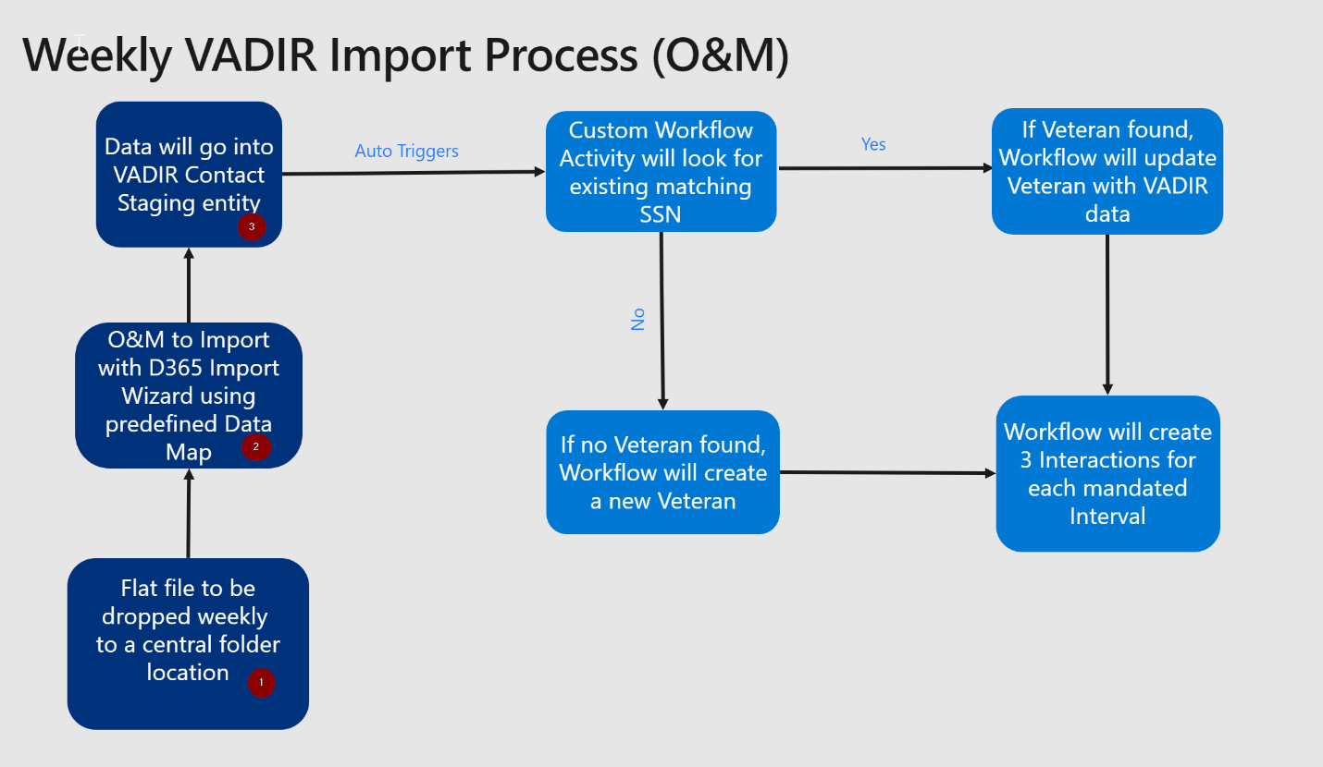

Diagram 1.3: *steps marked with numbers are manual executed by O&M. The rest of the steps are done through workflow in the background. Error handling is explained in Section 6.

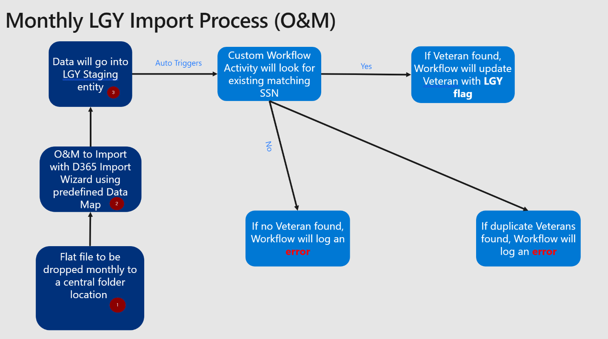

Diagram 1.4: *steps marked with numbers are manual executed by O&M. The rest of the steps are done through workflow in the background. Error handling in explained in Section 6.

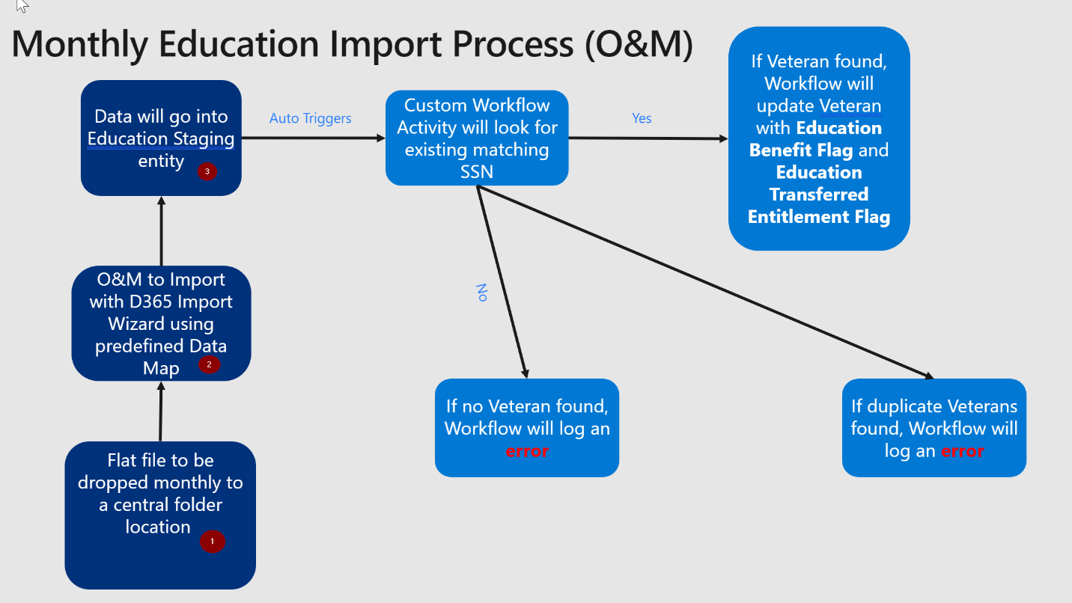

Diagram 1.5: *steps marked with numbers are manual executed by O&M. The rest of the steps are done through workflow in the background. Error handling is explained in Section 6.

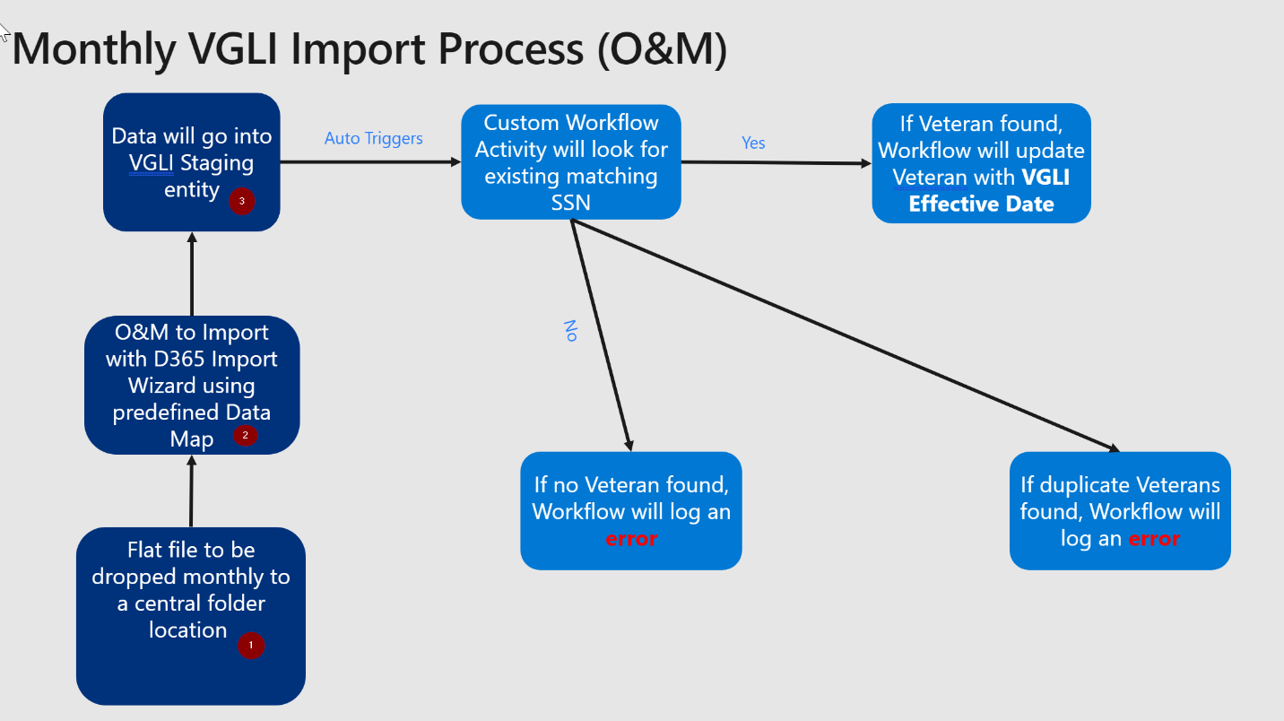

1. Data Map
2. Steps to Obtain Flat Files using Reflection FTP

Steps to obtain flat file:

1. Launch Reflection FTP app on your workstation

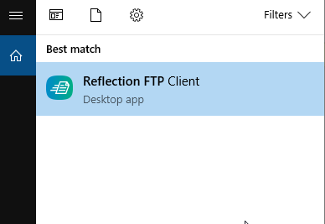

1. Click New

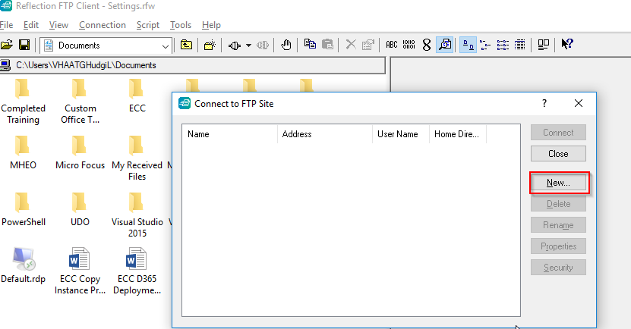

1. Enter the location of the Unix files. Details sent securely to individual users based on need.
2. Ensure your settings match the following:

Machine generated alternative text:
SSH protocoi 2 
Ciphei List 
AES 128 
AES 128 
AES 182 
AES 182 cbc 
AES 256 
PF.R 
Key Exchange Algorithms: 
DH Group SHA2SS 
DH E, SHAT 
DH SHAI 
Signature types 
RSA: SHAI 
SSH protocol I 
HMAC 
51-14258 
SHAI 
SHA512 
OSA: 
SHAI iav,' 
Run in AP 
cds 

1. Steps to Import VADIR File

Steps for import:

1. Obtain the VADIR file using Reflection FTP steps above. The file name follows the pattern MHEOYYYYMMDD.txt (i.e. MHEO20191016.txt)
2. Go to Production environment at [https://dvagov-udo-prod4.crm9.dynamics.com/](https://dvagov-udo-prod4.crm9.dynamics.com/main.aspx)
3. Go to Settings -> Data Management -> Imports

1. Launch Import Data Tool under Settings → Data Management → Imports

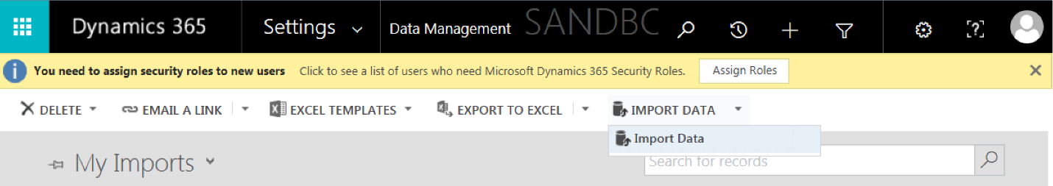

1. Upload production-ready VADIR data file.

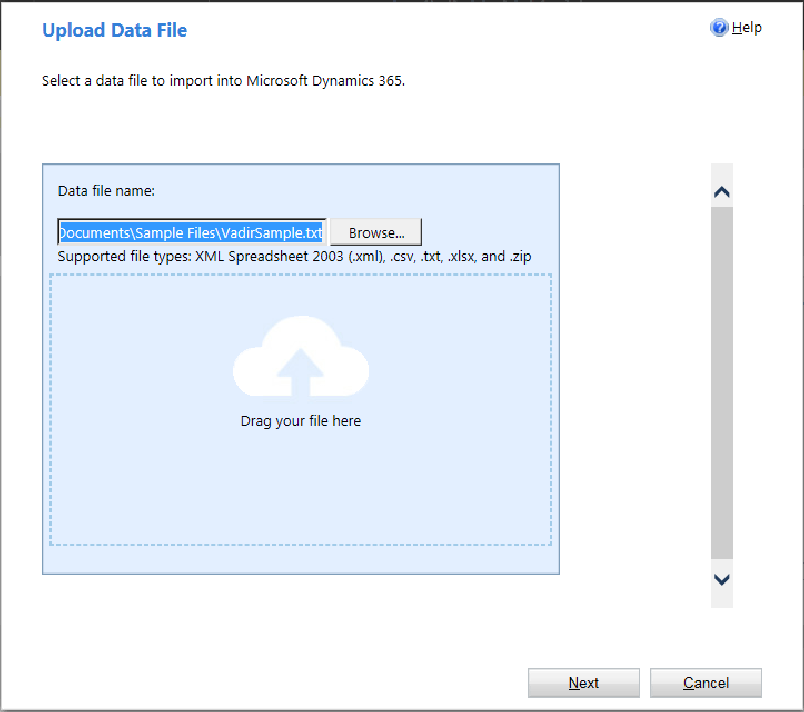

1. Click Next and expand the Delimiter Settings section. Set the Field delimiter to “Colon” and Data delimiter to “None”.

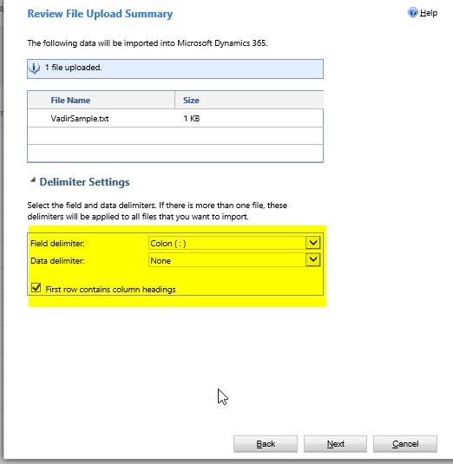

1. Click Next to reach Select Data Map Page.
2. Select predefined VadirContactStaging under Customized Data Maps section.

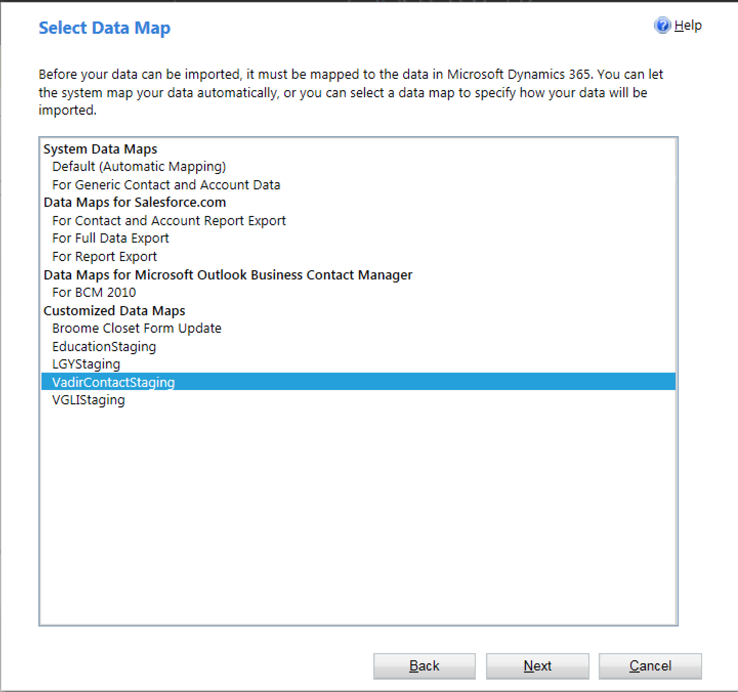

1. Pick VADIR Contact Staging in the Microsoft Dynamics 365 Record Types Dropdown.

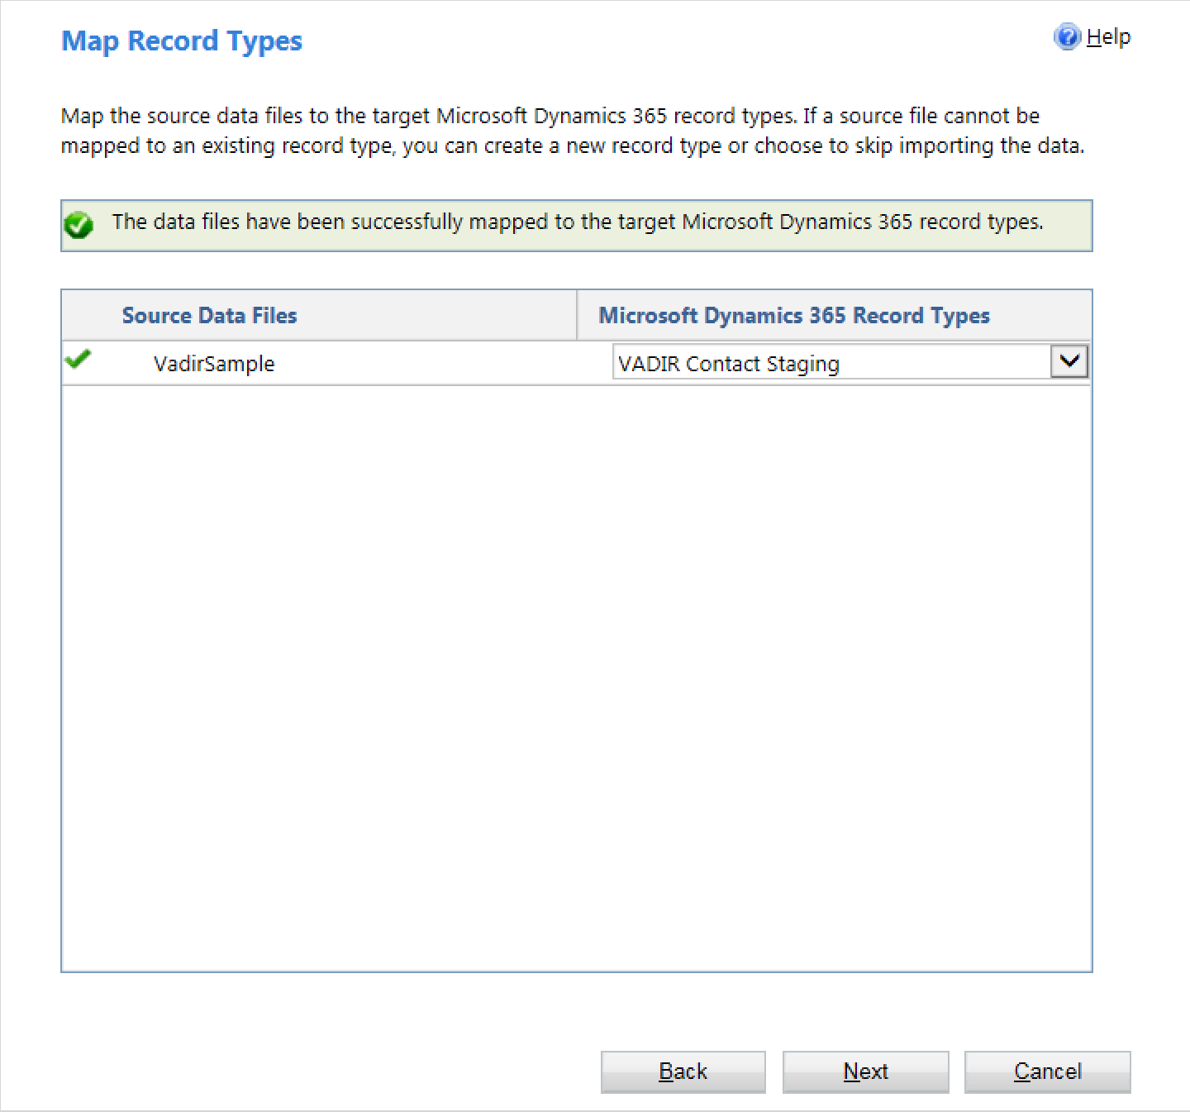

1. Review Mapping on the Map Fields Page. It should be one to one mapping.

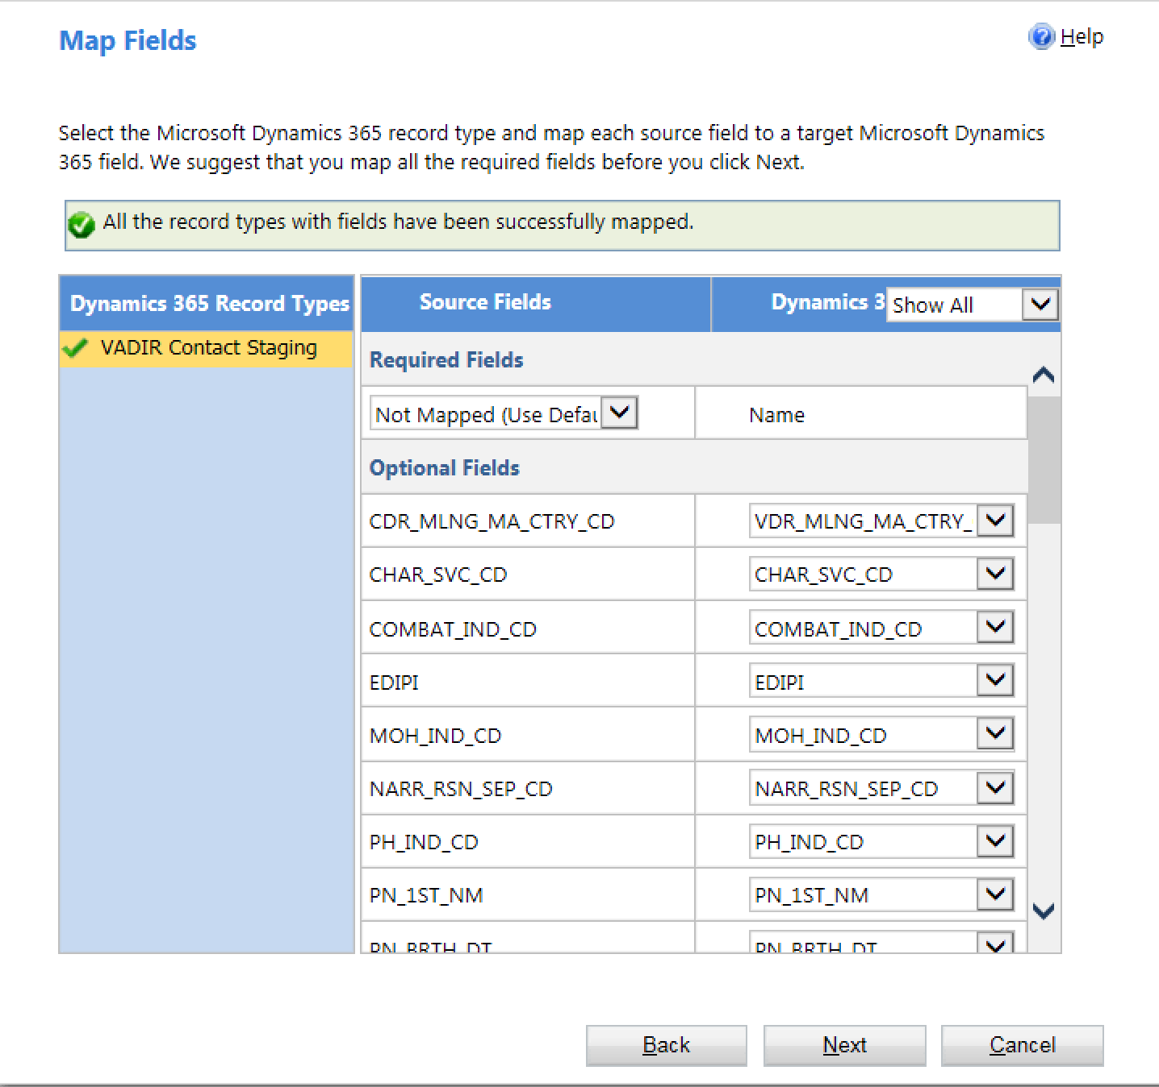

1. Click Next and Next to submit the mapping.
2. Go back to Settings → Data Management → Imports to check import status and review any failures.

1. Steps to Import Education File
2. Obtain the Education file using Reflection FTP steps above. The file name follows the pattern RITA_2019_14857_RESULTS_YYYYMM.txt (i.e. RITA_2019_14857_RESULTS_201910.txt).
3. Go to Production environment [https://dvagov-udo-prod4.crm9.dynamics.com/](https://dvagov-udo-prod4.crm9.dynamics.com/main.aspx)
4. Go to Settings → Data Management → Imports.

1. Launch Data Import Tool



1. Upload production-ready Education Data File.

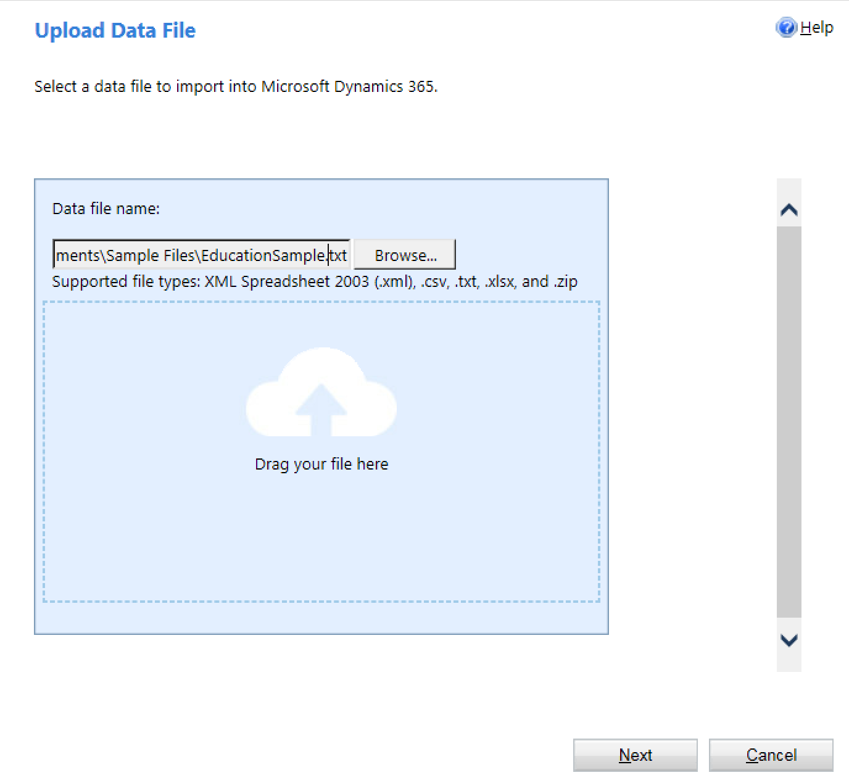

1. Click Next and expand the Delimiter Settings section. Set the Field delimiter to “Tab” and Data delimiter to “None”.

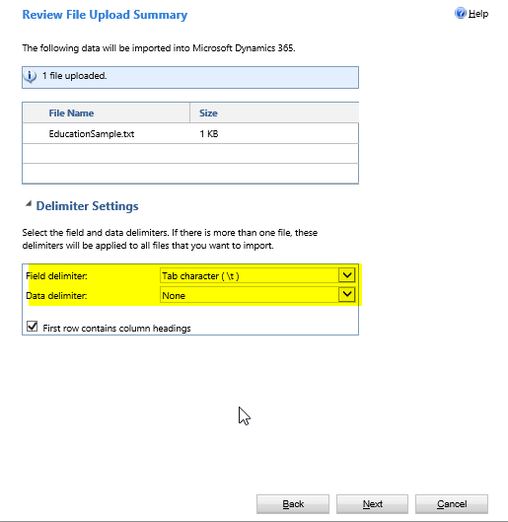

1. Click Next to reach Select Data Map page.
2. Pick EducationStaging under Customized Data Map section.

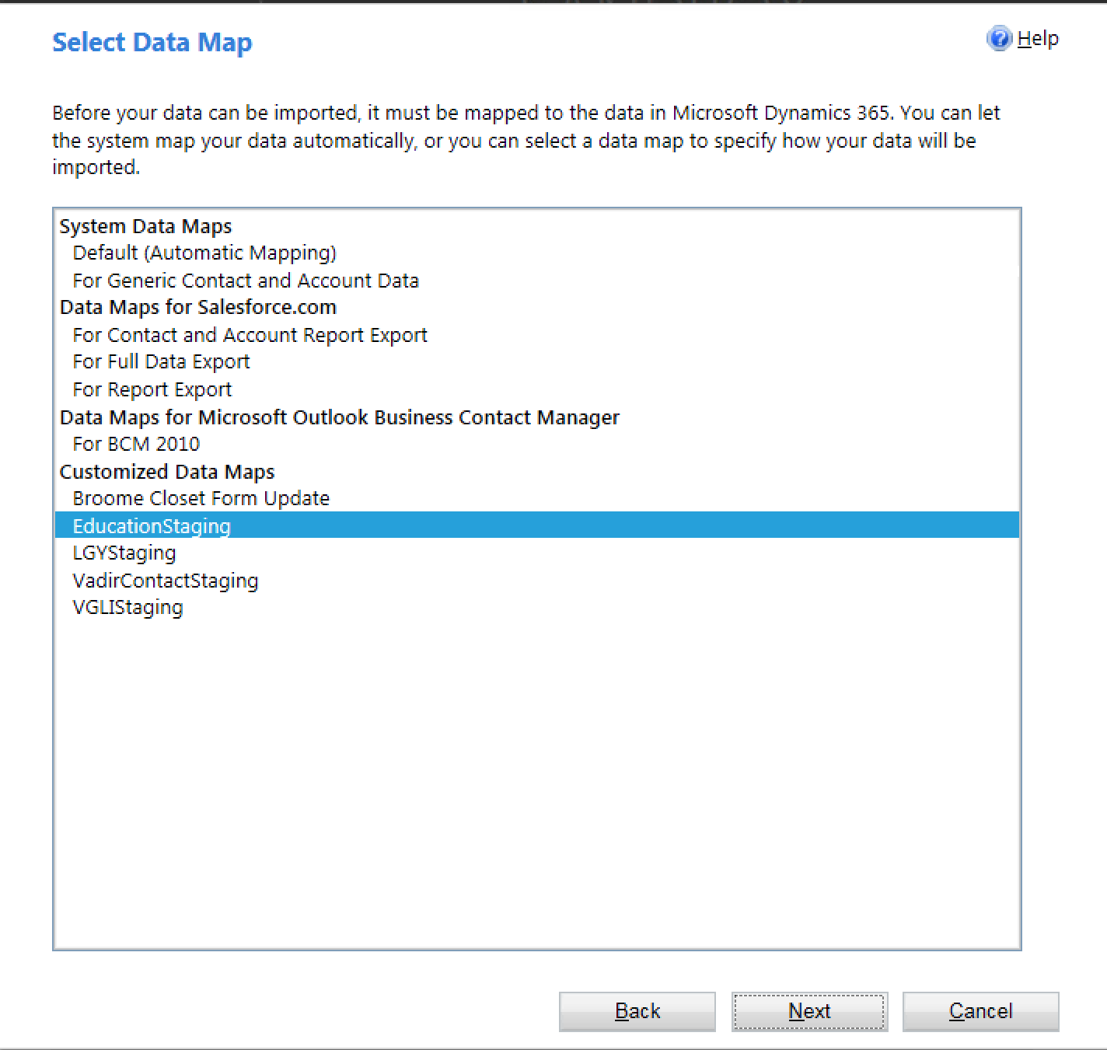

1. Select Education Staging in the Microsoft Dynamics 365 Record Types Dropdown.

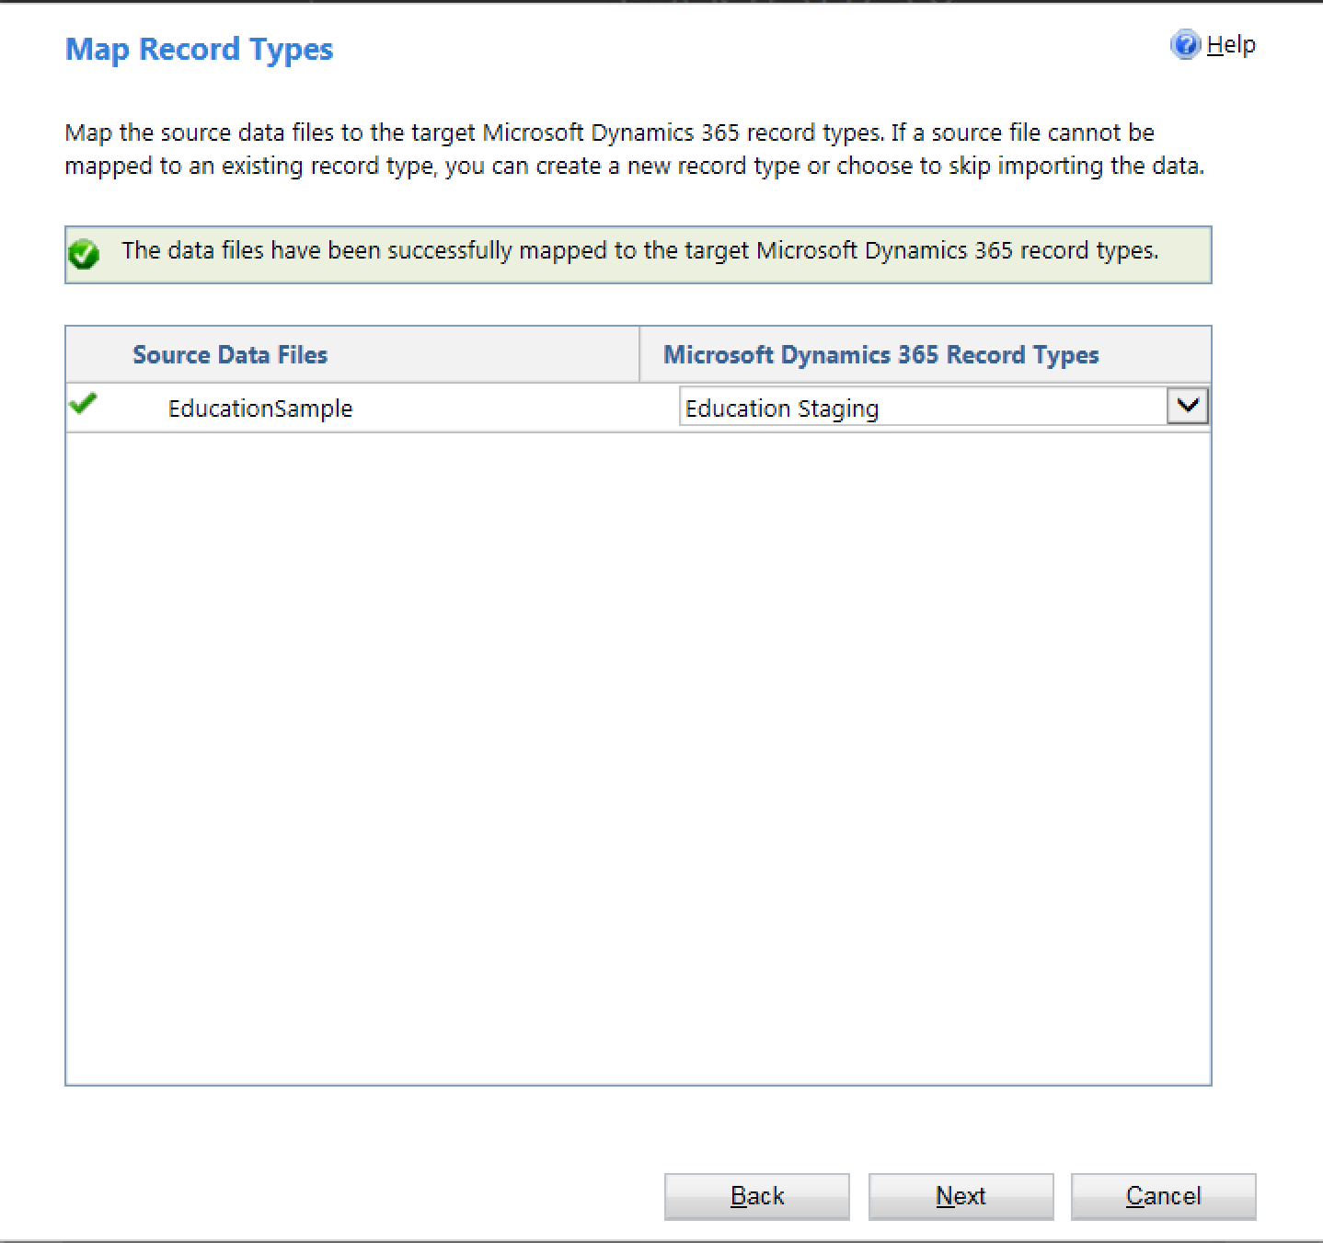

1. Review Mapping on the Map Fields Page. It should be one on one mapping.

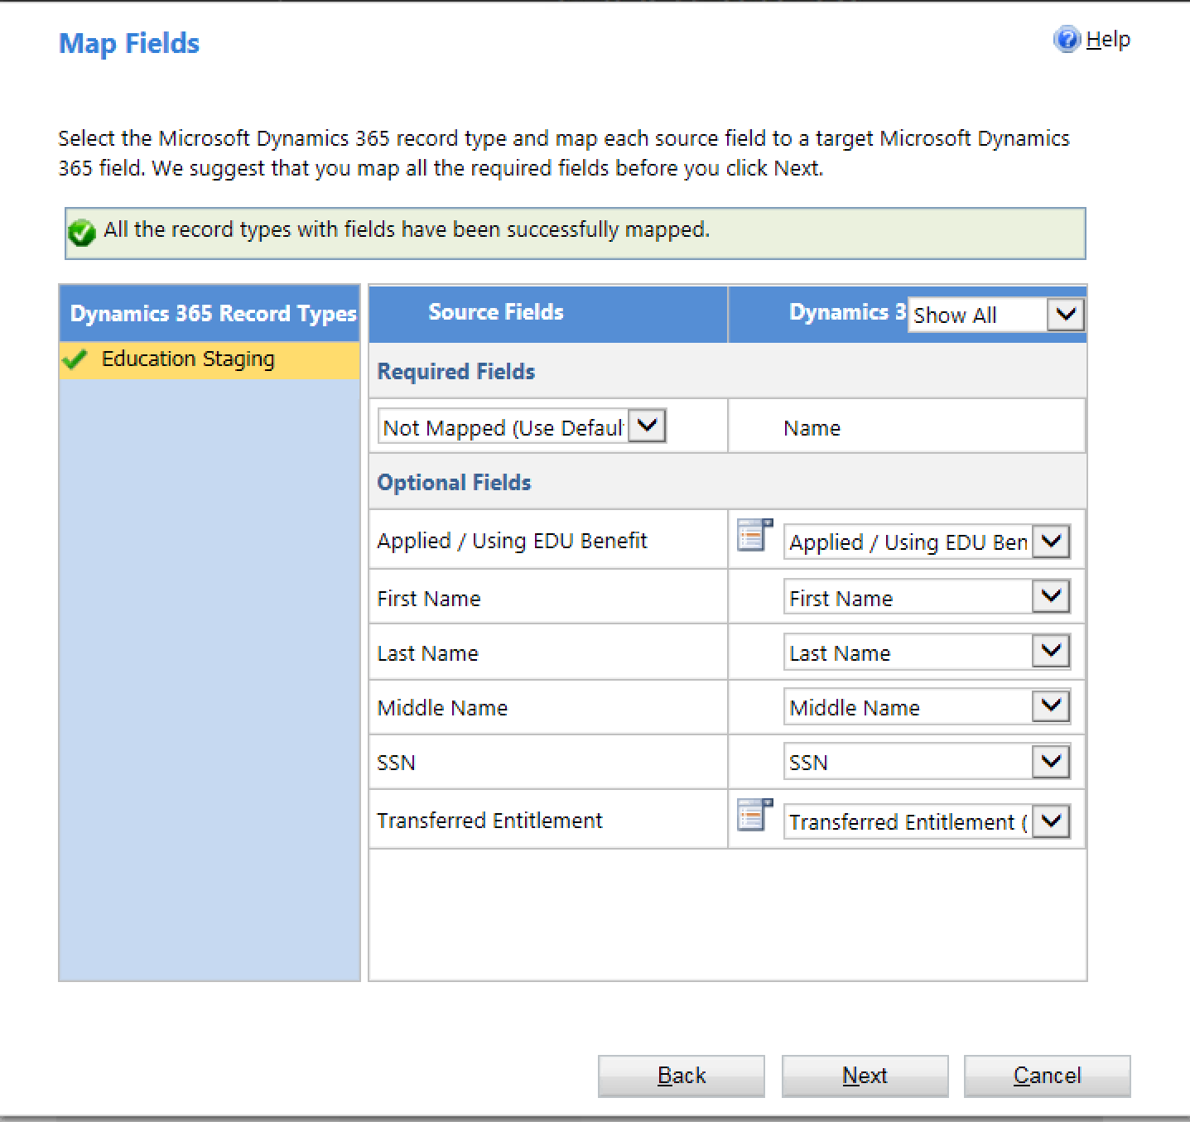

1. Click Next and Next to submit the mapping.
2. Go back to Settings → Data Management → Imports to check import status and review any failures.

1. Steps to Import LGY File
2. Obtain the LGY file using Reflection FTP steps above. The file name follows the pattern RITA_2019_14736_RESULTS_YYYYMM.txt (i.e. RITA_2019_14736_RESULTS_201910.txt).
3. Go to Production environment [https://dvagov-udo-prod4.crm9.dynamics.com/](https://dvagov-udo-prod4.crm9.dynamics.com/main.aspx)
4. Go to Settings -> Data Management -> Imports

1. Launch Data Import Tool



1. Upload production-ready LGY Data File.

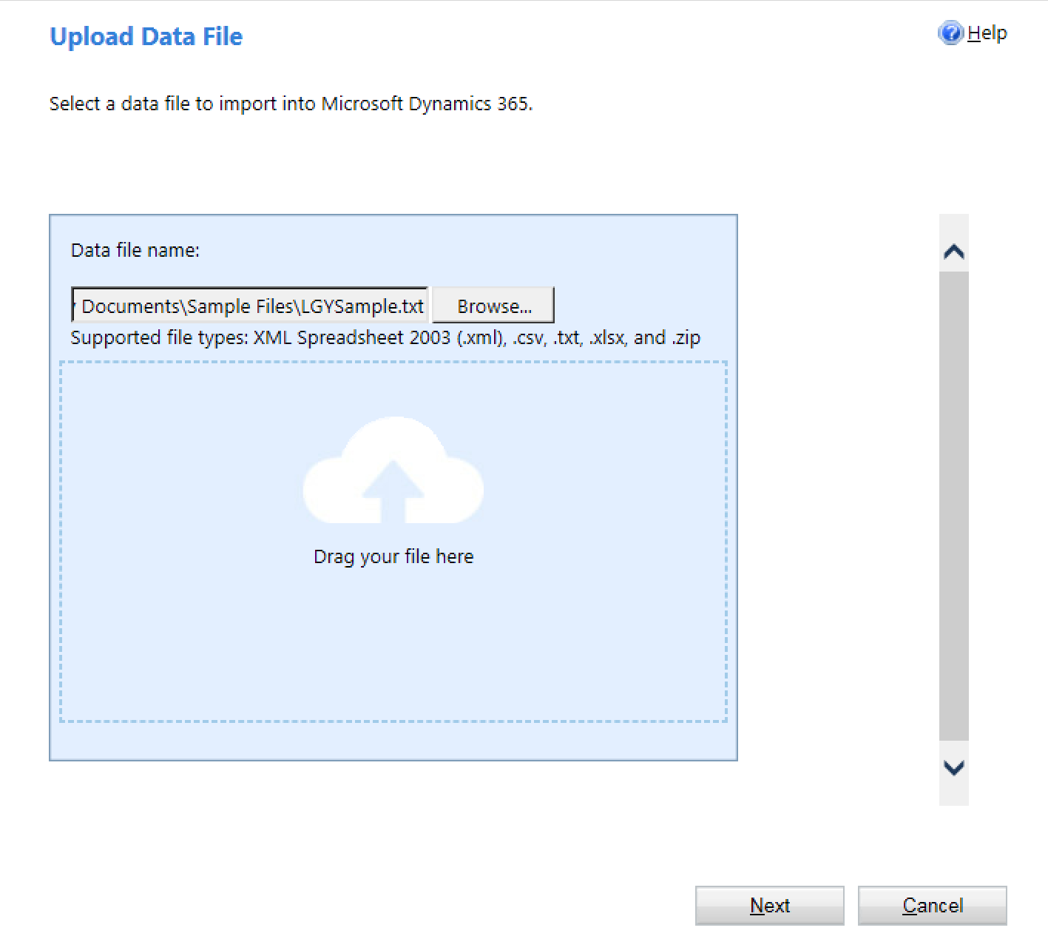

1. Click Next and expand the Delimiter Settings section. Set the Field delimiter to “Tab” and Data delimiter to “None”.

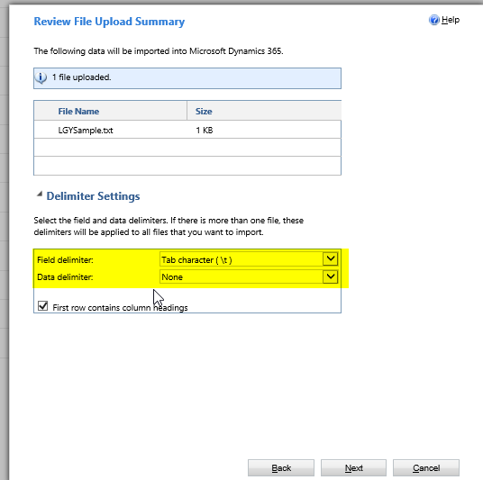

1. Click Next to reach Select Data Map page.
2. Pick LGYStaging under Customized Data Map section.

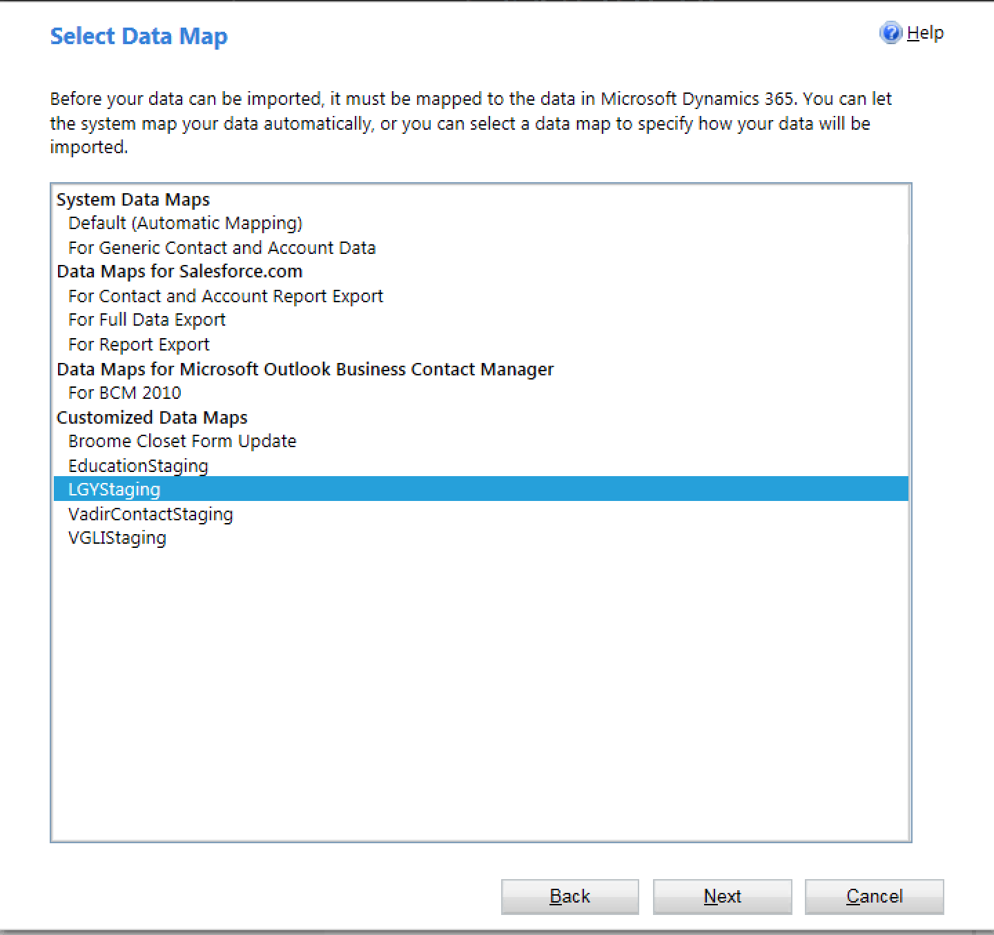

1. Pick LGY Staging under the Microsoft Dynamics 365 Record Types.

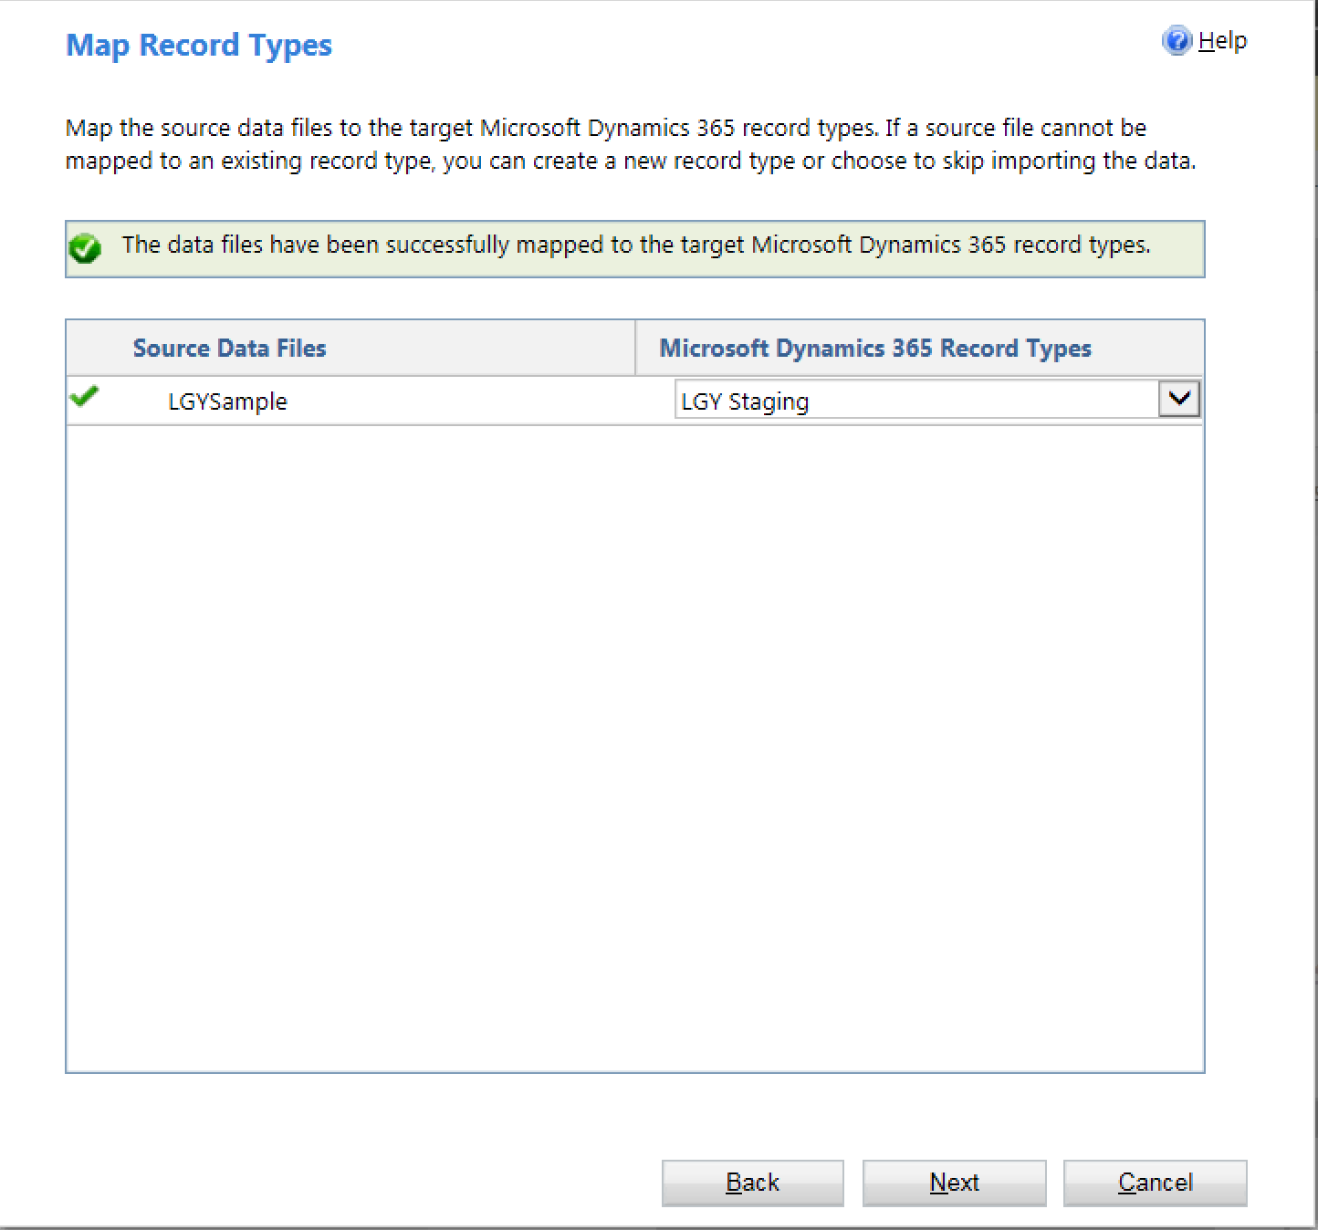

1. Review Mapping on the Map Fields Page.

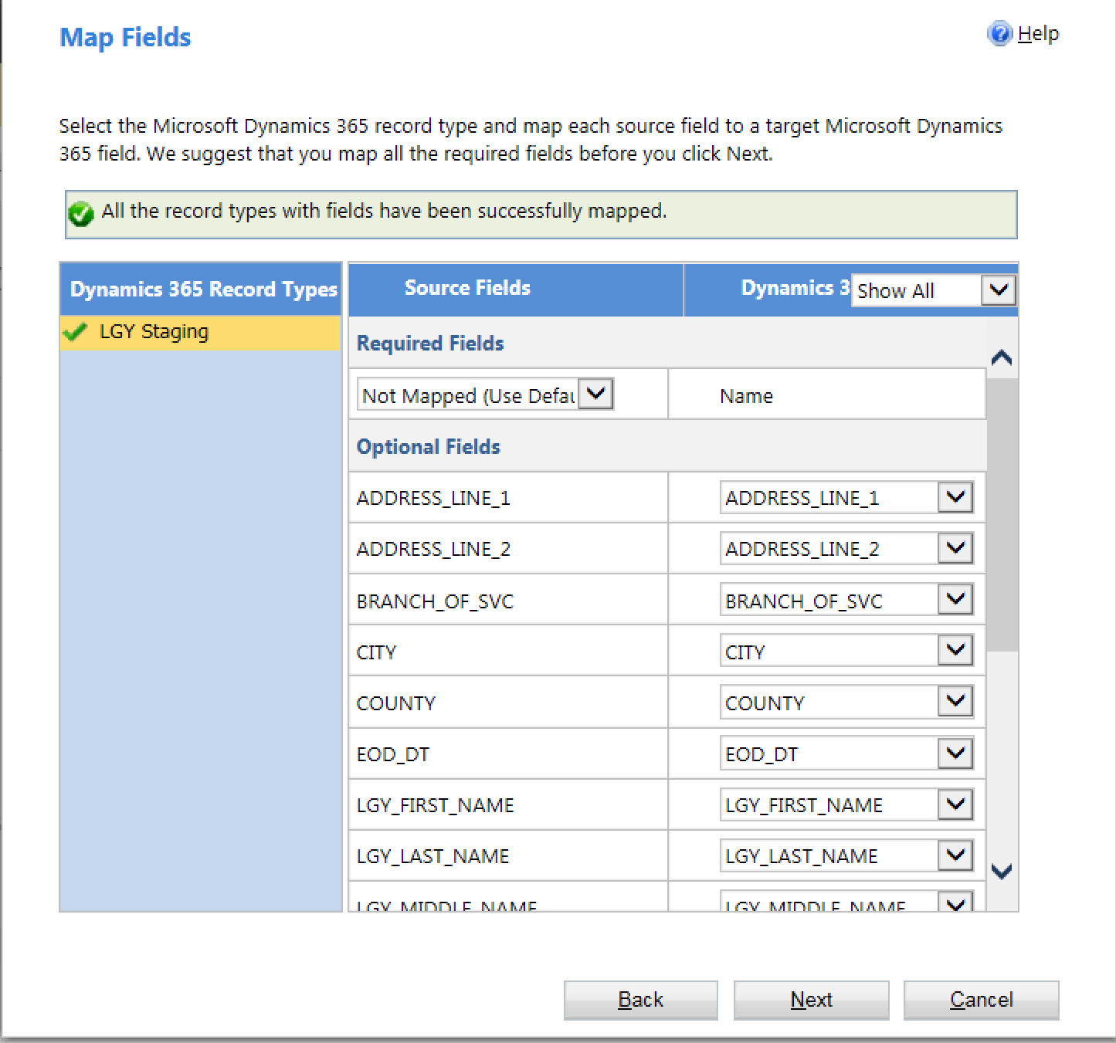

1. Click Next and Next to submit the mapping request.
2. Go back to Settings → Data Management → Imports to check import status and review any failures.

1. Steps to Import VGLI File
2. Obtain the VGLI file using Reflection FTP steps above. The file name follows the pattern TBD (i.e. TBD).
3. Open the VGLI file in Excel and click File → Save As →This PC. Choose CSV (Comma delimited) (*.csv) as the file type. Then click the Save button.

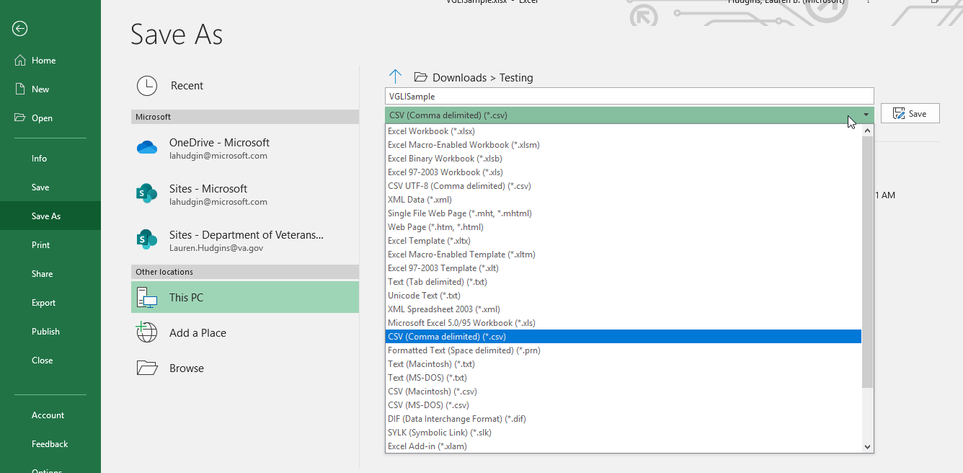

1. Go to Production environment [https://dvagov-udo-prod4.crm9.dynamics.com/](https://dvagov-udo-prod4.crm9.dynamics.com/main.aspx)
2. Go to Settings → Data Management → Imports.A screenshot of a social media post

   Description automatically generated
3. Launch Data Import Tool



1. Upload production-ready VGLI Data File.

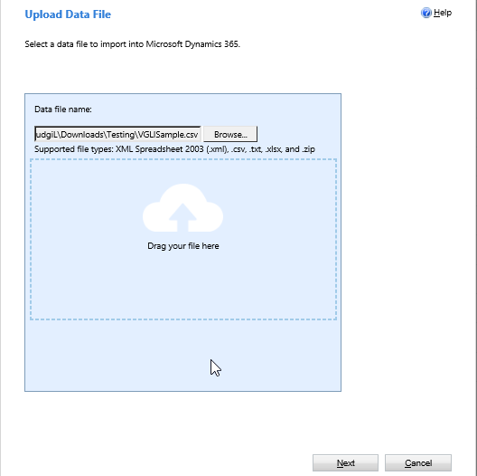

1. Click Next and accept the default Delimiter Settings.

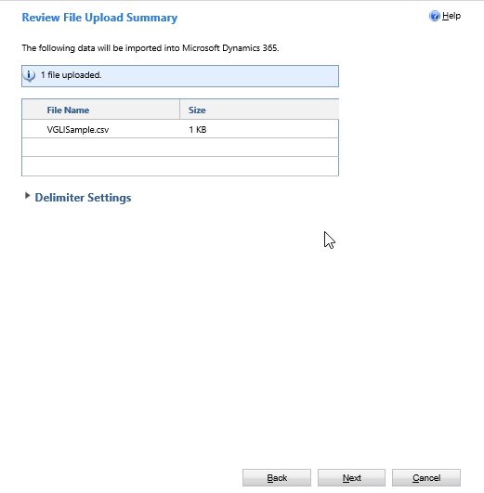

1. Click Next to reach Select Data Map Page.
2. Pick predefined VGLIStaging under the Customized Data Maps Section.

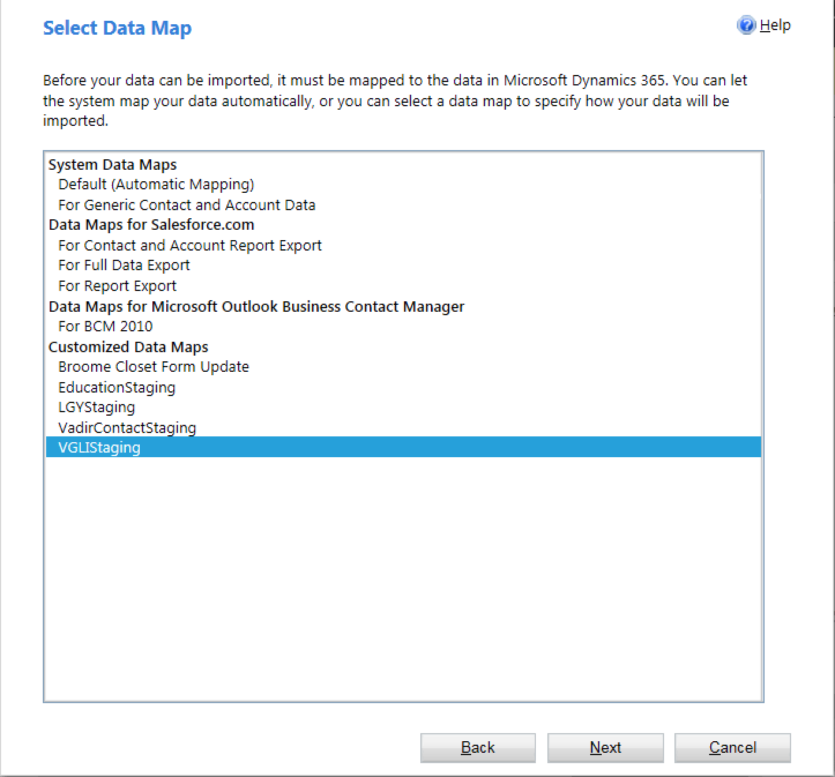

1. Pick VGLI Staging under the Microsoft Dynamics 365 Record Types.

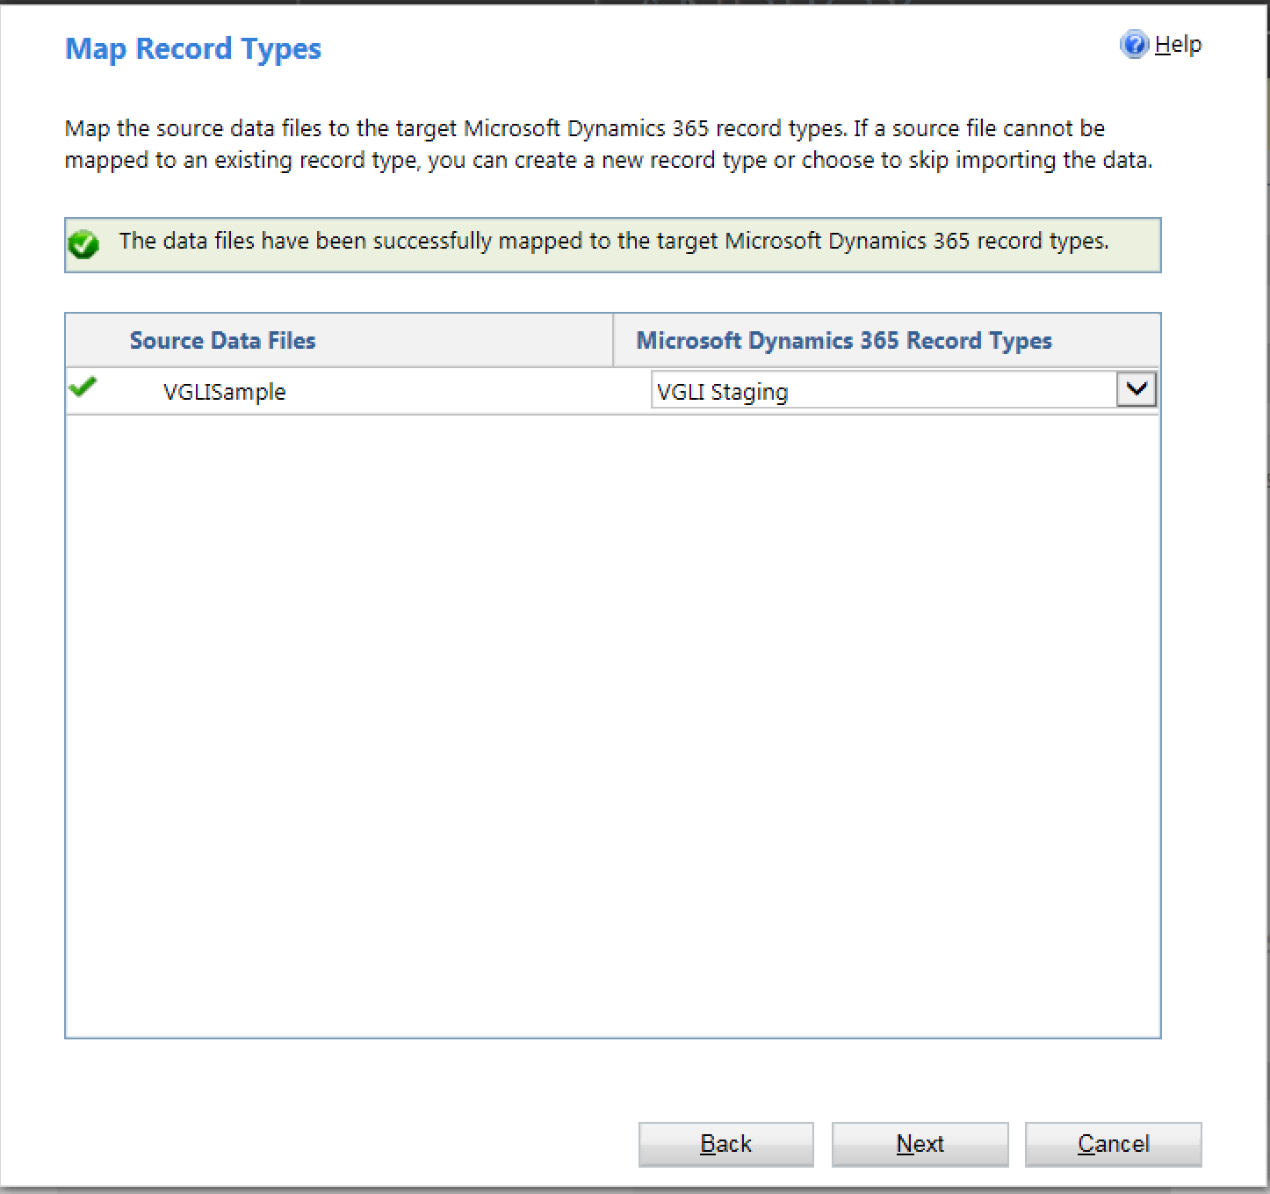

1. Review Mapping on the Map Fields Page. Note that only Member Status Effective Date and SSN are mapped.

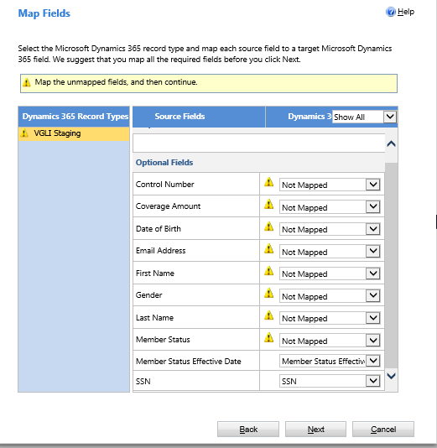

1. Click Next and select OK to the following prompt.

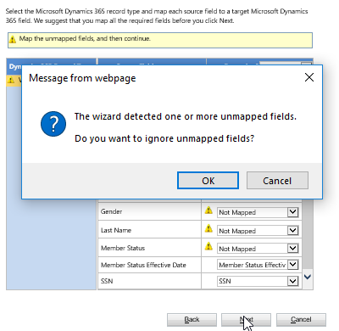

1. Click Next again to submit the mapping request.
2. Go back to Settings → Data Management → Imports to check import and review any failures.

1. Error Troubleshooting
   1. MHEO Import Summary Report
2. Go to Settings 🡪 Workplace🡪 Reports

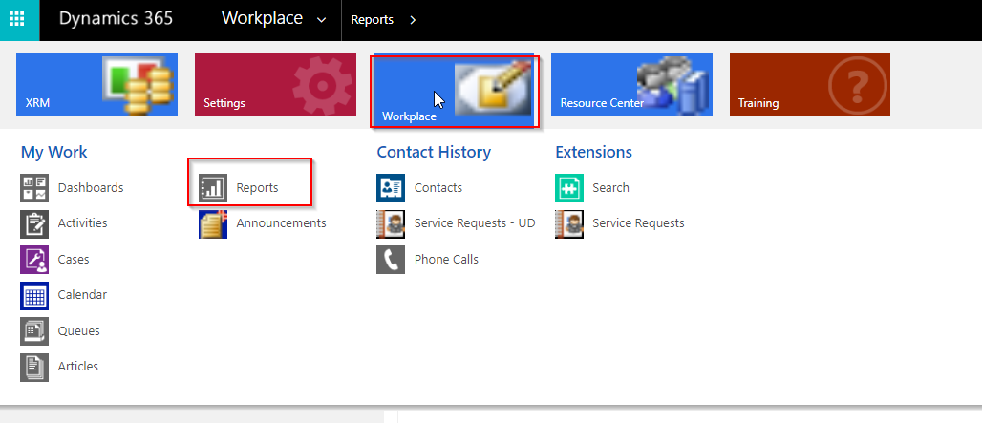

1. Switch the view to Administrative Reports and double click MHEO Import Summary.

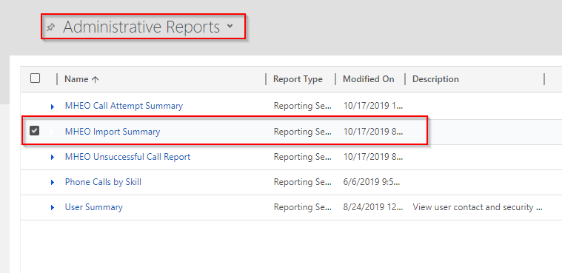

1. Select the date if other than today, the Import Type and the Process Name applicable to your needs. Click the “+” to view additional details where applicable.

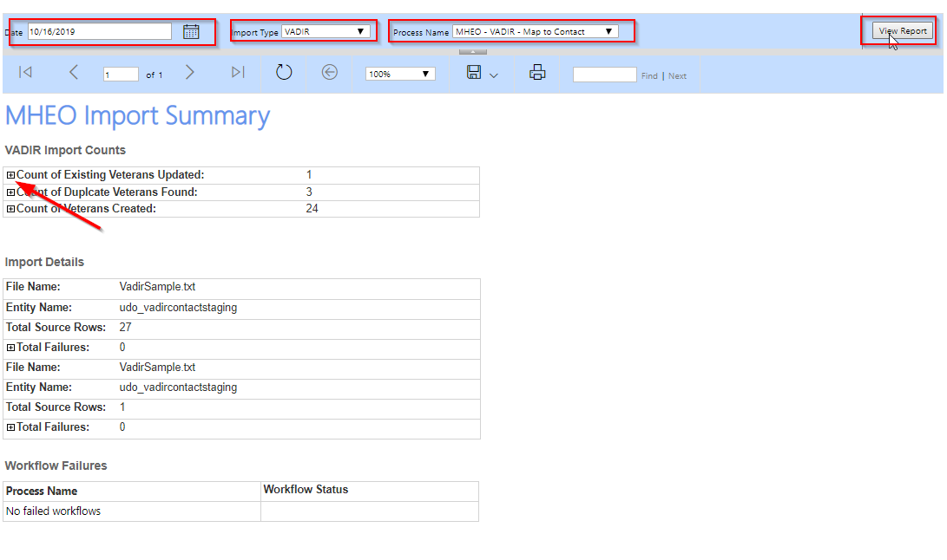

1. Note that if duplicate Veterans are found, no interactions will be created for that Veteran.
   1. Import Logs View

1) Go to Settings -> Data Management -> Imports -> My imports.

2) Double click on the row to check errors.

3) Click on Failures in the left navigation pane. It shows specific errors in the description column. Error 2&3 below mean PNL_BGN_DT column contains wrong format. If you need any assistance, please reach out to Microsoft.

4) Click on Export Error Rows and save it to a local folder.

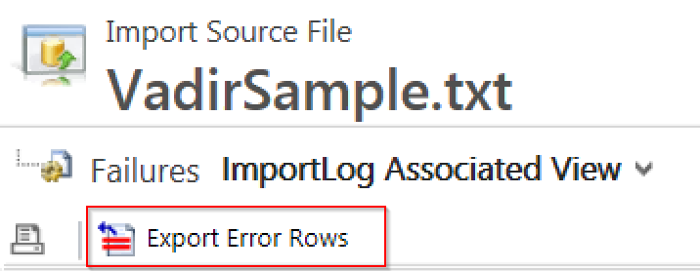

5) Edit the file in Notepad or Notepad++ and fix the erroneous data if possible. 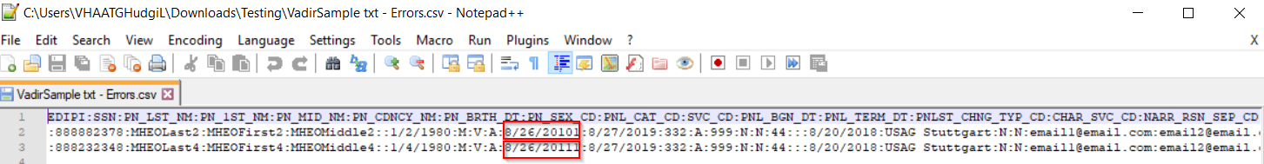

6) Re-import it back successfully. Refer to Section 2 – 5 for specific import steps.

* 1. MHEO Map Workflow Errors View

A custom view can be created and shared among users for troubleshooting workflow errors. A brief mapping is illustrated below to show which workflow carries what data.

|  |  |  |
| --- | --- | --- |
| **Source Staging Entity** | **Workflow** | **Destination Entity** |
| VADIR Contact Staging | MHEO - VADIR - Map to Contact | Contact |
| Education Staging | MHEO - Education - Map to Contact | Contact |
| LGY Staging | MHEO - LGY - Map to Contact | Contact |
| VGLI Staging | MHEO - VGLI - Map to Contact | Contact |

Steps to create the view:

1. Go to Settings → System Jobs

1. Go to Advanced Find. A screenshot of a cell phone

   Description automatically generated
2. The “Look for:” will indicate “System Jobs” in the entity dropdown. Add the criteria shown below. A screenshot of a social media post

   Description automatically generated
3. Click Save and name it “MHEO Map Workflow Errors”.
4. Click on the Results button and erroneous workflow executions will be displayed.

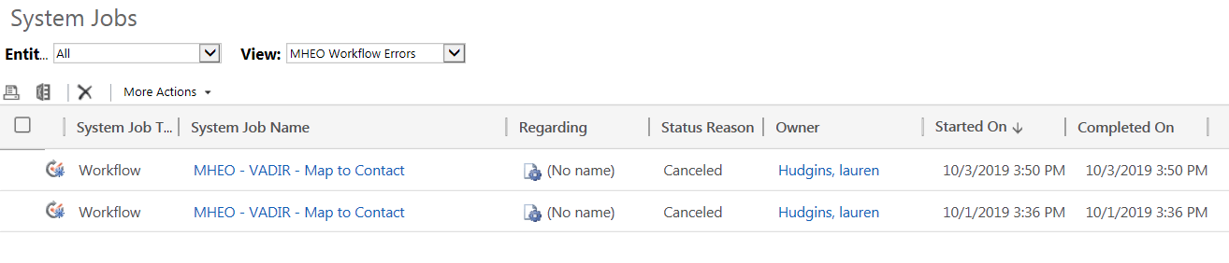

1. Click on the System Job Name column to check the erroneous workflow step. Please note a canceled workflow often means it found duplicate Veteran records. If you need any assistance troubleshooting workflows, please reach out to Microsoft.